Cans for robotics competitions

Patrick R. Michaud, pmichaud@pobox.com

2014.12.02

Here are the steps I used to create the duct-tape covered cans for DPRG robotics competitions.

1. Start with a standard 12-ounce aluminum soda can. I used Dr. Pepper cans, because... well, it's obvious.
2. Drill two 1/8” holes on the side of the can to empty its contents. I drilled the first hole approximately 1 inch from the top of the can, and the second hole immediately above the bottom rim. I used the can's graphics to align the two holes.

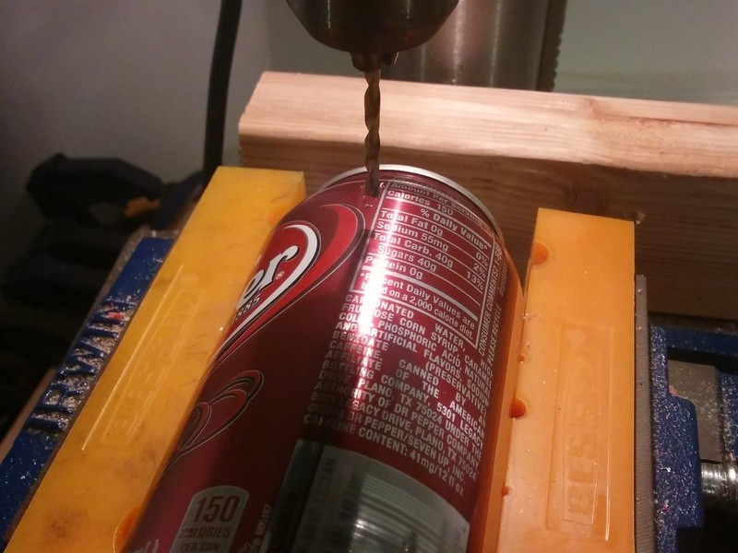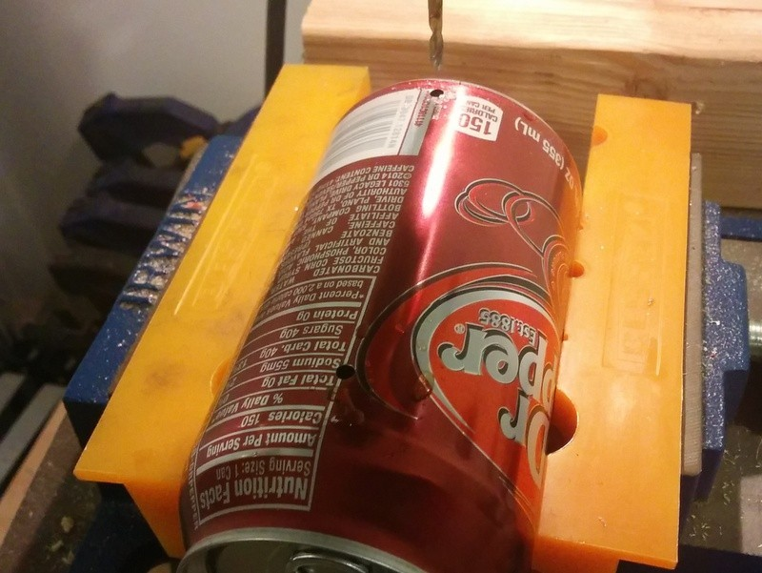

1. Place the can over a sink and allow the contents to drain out. As the can nears empty, you can tip the can to drain it completely. (I don't recommend consuming the drink, as there could be aluminum shards in it from the drilling process.)

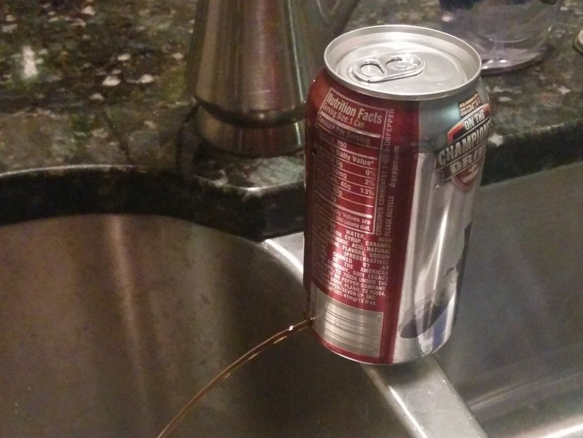

1. Refill the can with water and shake to rinse out any remaining soda, then drain it again. I did this twice for each can.
2. Shake out as much liquid as possible, then let the can sit a few hours to completely drain/dry out.
3. Wrap the bottom of the can with 1.75” neon orange Duck Tape (product number 868090). I aligned the bottom edge of the tape with just above the bottom rim taper and went around the can twice so that there are two layers of Duck Tape around the side of the can.

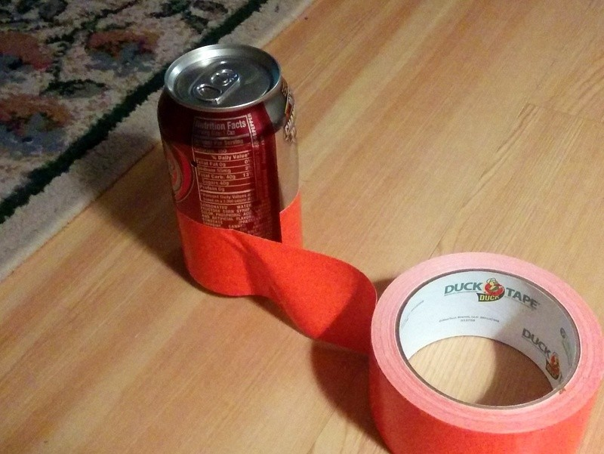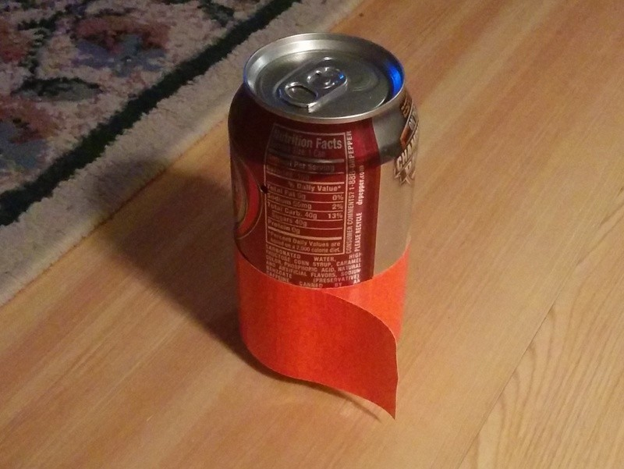

1. Using a sharp knife, score the top layer of tape at the point where it starts a third trip around the can. If you press on the tape you can easily find the “ridge” where the tape started and score there. (I also used the can's graphic markings to keep track of where the tape started.) With the top layer scored, it's easy to remove any excess tape to produce a uniform two-tape layer around the can.

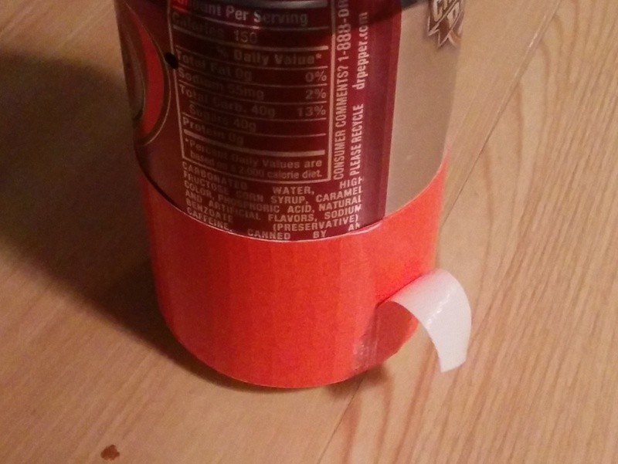

1. Punch a ventilation hole in the tape over the hole used to drain the contents. Without at least one ventilation hole, the can will be airtight and will crumple/balloon in response to changes in external barometric pressure.

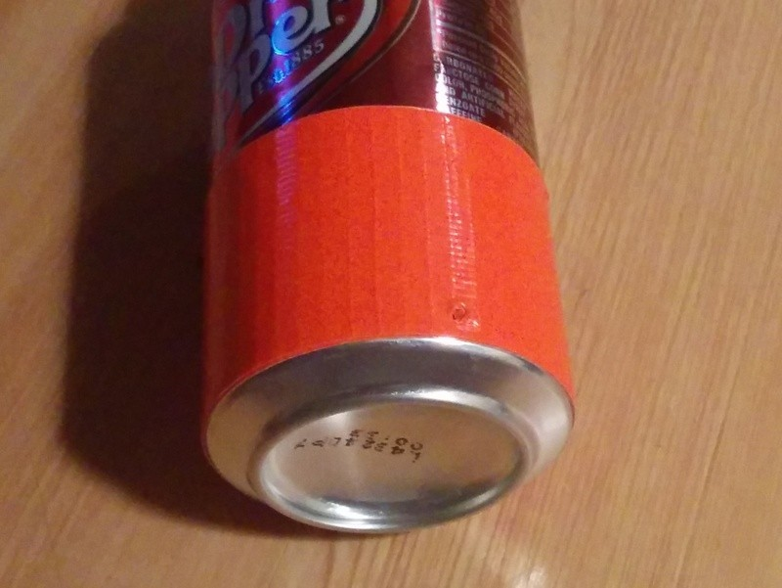

1. Wrap another two layers of tape immediately above the layers added in the steps above. Again score the tape where it starts to produce a third trip around the can and remove any excess.

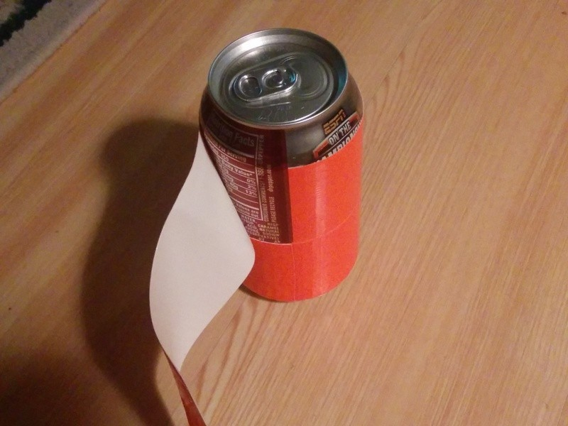

1. Wrap a single layer of tape around the top of the can, flush with the tape added in the previous step. Only one trip around the can is needed here, and because of the taper at the rim the tape will likely have a lot of wrinkles in it. Smooth them out as best as you can.

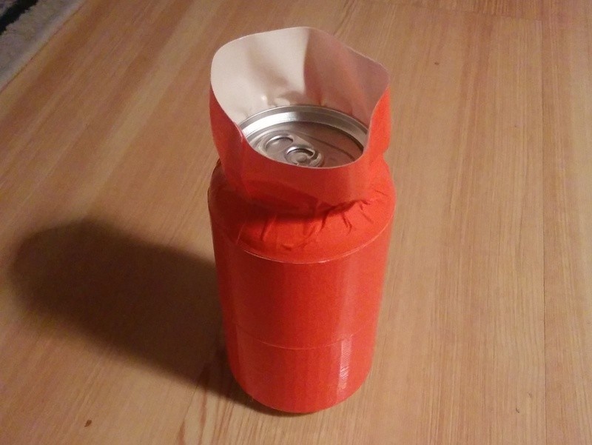

1. Cut and remove the tape just below the top rim of the can.

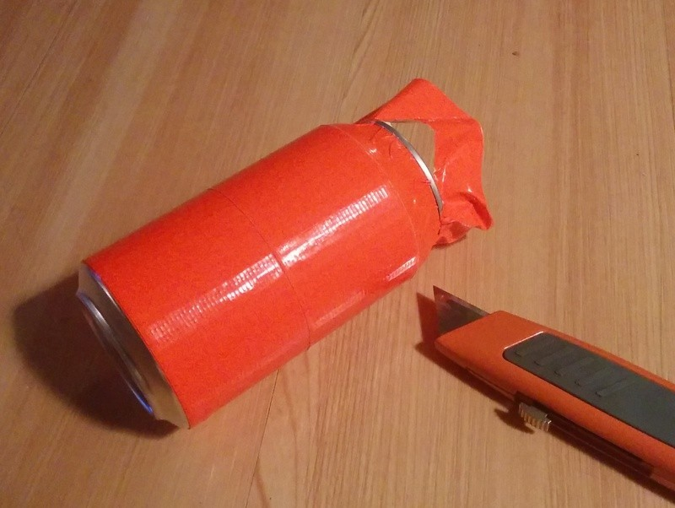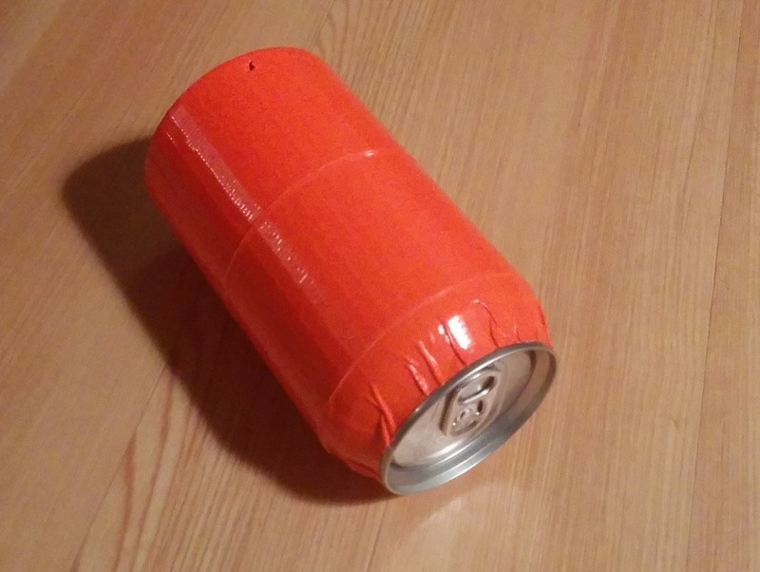

1. You're finished. Enjoy a soda or other cool beverage!